TOPIC 01:

KIRCHOFF’S CURRENT LAW:

The sum of all currents entering a junction (or node) in an electrical circuit is equal to the sum of all currents leaving the node.

∑Iin=∑Iout

TOPIC 02:

KIRCHOFF’S VOLTAGE LAW:

***“The algebraic sum of all voltages in a loop must equal zero”***

∑V = 0

TOPIC 03:

LOGIC GATES:

**Basic Logic Gates**

* **AND Gate**: Performs logical multiplication. It generates a high output only when all inputs are high[**1**](https://www.bing.com/ck/a?!&&p=c9f30e9ba5f7d51117f5ca72f2883fcdcfa1f13d328f5c1825bcb3b220a3603fJmltdHM9MTc1MTU4NzIwMA&ptn=3&ver=2&hsh=4&fclid=22b5b4a9-39f6-67d6-1561-a2b13804661b&u=a1aHR0cHM6Ly93d3cuZ2Vla3Nmb3JnZWVrcy5vcmcvbG9naWMtZ2F0ZXMv&ntb=1). A B | A AND B 0 0 | 0 0 1 | 0 1 0 | 0 1 1 | 1
* **OR Gate**: Performs logical addition. It generates a high output when at least one input is high[**1**](https://www.bing.com/ck/a?!&&p=c9f30e9ba5f7d51117f5ca72f2883fcdcfa1f13d328f5c1825bcb3b220a3603fJmltdHM9MTc1MTU4NzIwMA&ptn=3&ver=2&hsh=4&fclid=22b5b4a9-39f6-67d6-1561-a2b13804661b&u=a1aHR0cHM6Ly93d3cuZ2Vla3Nmb3JnZWVrcy5vcmcvbG9naWMtZ2F0ZXMv&ntb=1). A B | A OR B 0 0 | 0 0 1 | 1 1 0 | 1 1 1 | 1
* **NOT Gate**: Inverts the input signal. It generates a high output when the input is low and vice versa[**1**](https://www.bing.com/ck/a?!&&p=c9f30e9ba5f7d51117f5ca72f2883fcdcfa1f13d328f5c1825bcb3b220a3603fJmltdHM9MTc1MTU4NzIwMA&ptn=3&ver=2&hsh=4&fclid=22b5b4a9-39f6-67d6-1561-a2b13804661b&u=a1aHR0cHM6Ly93d3cuZ2Vla3Nmb3JnZWVrcy5vcmcvbG9naWMtZ2F0ZXMv&ntb=1). A | NOT A 0 | 1 ,1 | 0

**Universal Logic Gates**

* **NAND Gate**: Combination of AND and NOT gates. It generates a low output only when all inputs are high[**1**](https://www.bing.com/ck/a?!&&p=c9f30e9ba5f7d51117f5ca72f2883fcdcfa1f13d328f5c1825bcb3b220a3603fJmltdHM9MTc1MTU4NzIwMA&ptn=3&ver=2&hsh=4&fclid=22b5b4a9-39f6-67d6-1561-a2b13804661b&u=a1aHR0cHM6Ly93d3cuZ2Vla3Nmb3JnZWVrcy5vcmcvbG9naWMtZ2F0ZXMv&ntb=1). A B | A NAND B 0 0 | 1 0 1 | 1 1 0 | 1 1 1 | 0
* **NOR Gate**: Combination of OR and NOT gates. It generates a high output only when all inputs are low[**1**](https://www.bing.com/ck/a?!&&p=c9f30e9ba5f7d51117f5ca72f2883fcdcfa1f13d328f5c1825bcb3b220a3603fJmltdHM9MTc1MTU4NzIwMA&ptn=3&ver=2&hsh=4&fclid=22b5b4a9-39f6-67d6-1561-a2b13804661b&u=a1aHR0cHM6Ly93d3cuZ2Vla3Nmb3JnZWVrcy5vcmcvbG9naWMtZ2F0ZXMv&ntb=1). A B | A NOR B 0 0 | 1 0 1 | 0 1 0 | 0 1 1 | 0

**Derived Logic Gates**

* **XOR Gate**: Generates a high output when the inputs are different[**1**](https://www.bing.com/ck/a?!&&p=c9f30e9ba5f7d51117f5ca72f2883fcdcfa1f13d328f5c1825bcb3b220a3603fJmltdHM9MTc1MTU4NzIwMA&ptn=3&ver=2&hsh=4&fclid=22b5b4a9-39f6-67d6-1561-a2b13804661b&u=a1aHR0cHM6Ly93d3cuZ2Vla3Nmb3JnZWVrcy5vcmcvbG9naWMtZ2F0ZXMv&ntb=1). A B | A XOR B 0 0 | 0 0 1 | 1 1 0 | 1 1 1 | 0
* **XNOR Gate**: Combination of XOR and NOT gates. It generates a high output when the inputs are the same[**1**](https://www.bing.com/ck/a?!&&p=c9f30e9ba5f7d51117f5ca72f2883fcdcfa1f13d328f5c1825bcb3b220a3603fJmltdHM9MTc1MTU4NzIwMA&ptn=3&ver=2&hsh=4&fclid=22b5b4a9-39f6-67d6-1561-a2b13804661b&u=a1aHR0cHM6Ly93d3cuZ2Vla3Nmb3JnZWVrcy5vcmcvbG9naWMtZ2F0ZXMv&ntb=1). A B | A XNOR B 0 0 | 1 0 1 | 0 1 0 | 0 1 1 | 1

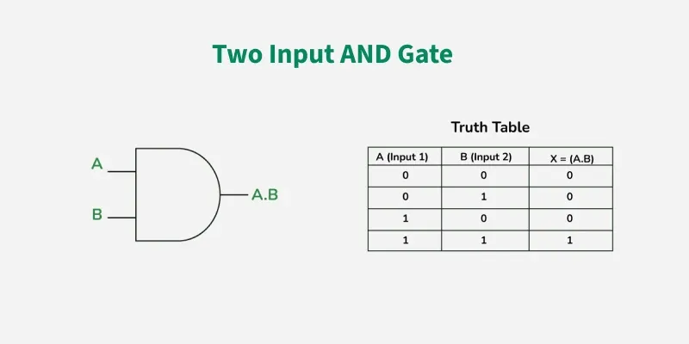

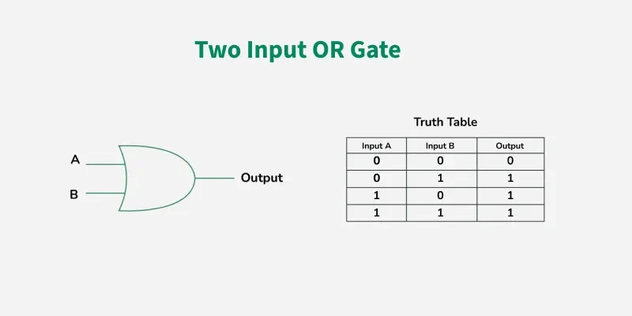

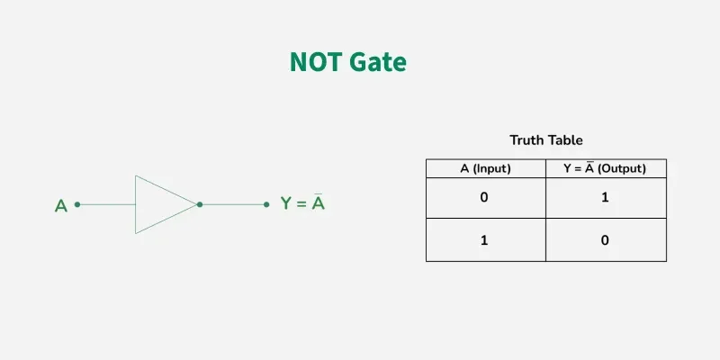

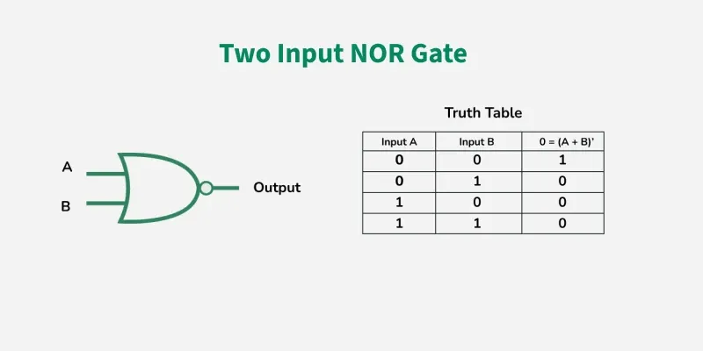

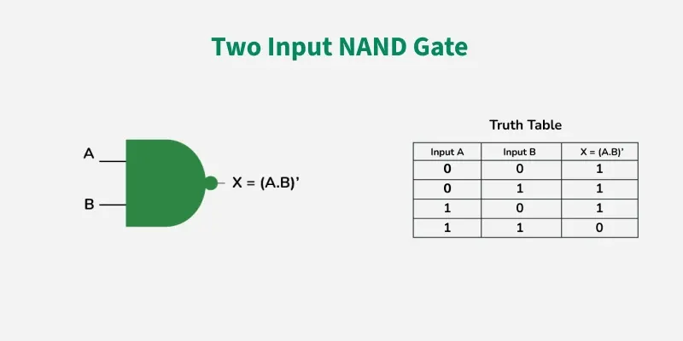

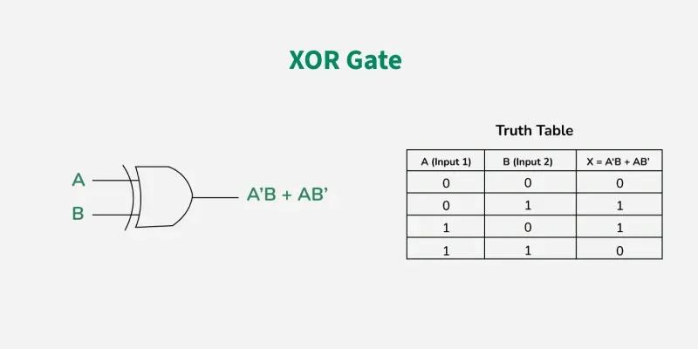

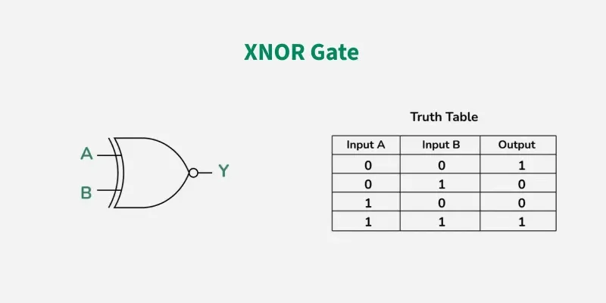

TOPIC 4:

MULTIPLEXER AND DEMULTIPLEXER;

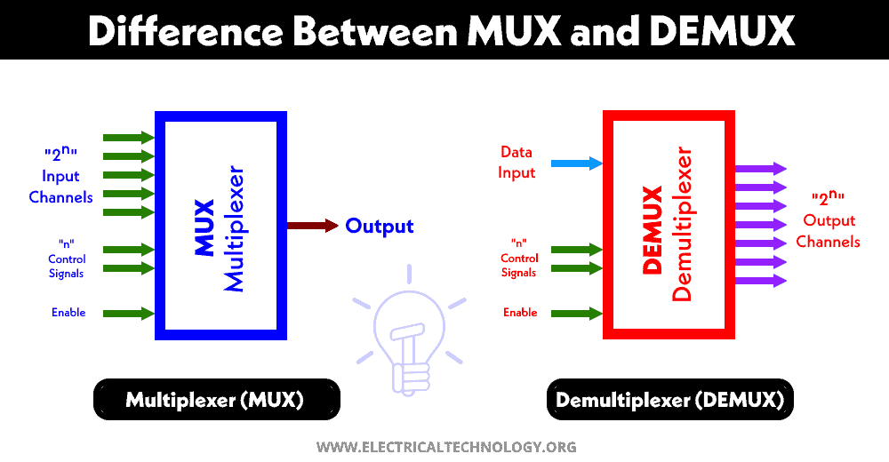

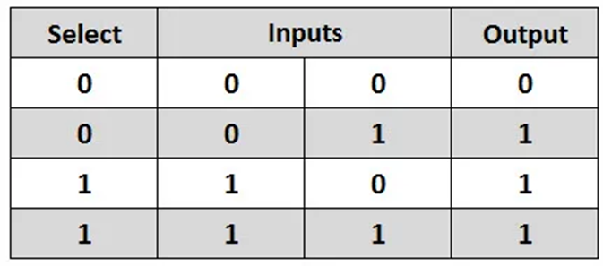

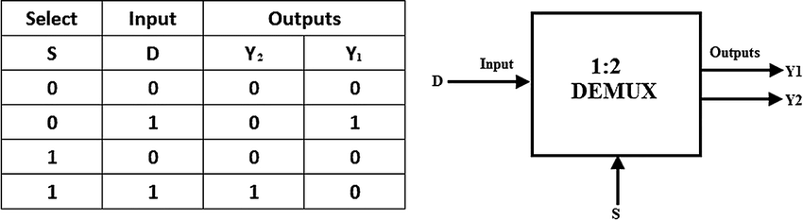

TOPIC 5:

ANALOG TO DIGITAL CONVERTER:

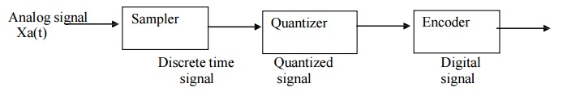

TOPIC 6:

DIGITAL TO ANALOG CONVERTOR:

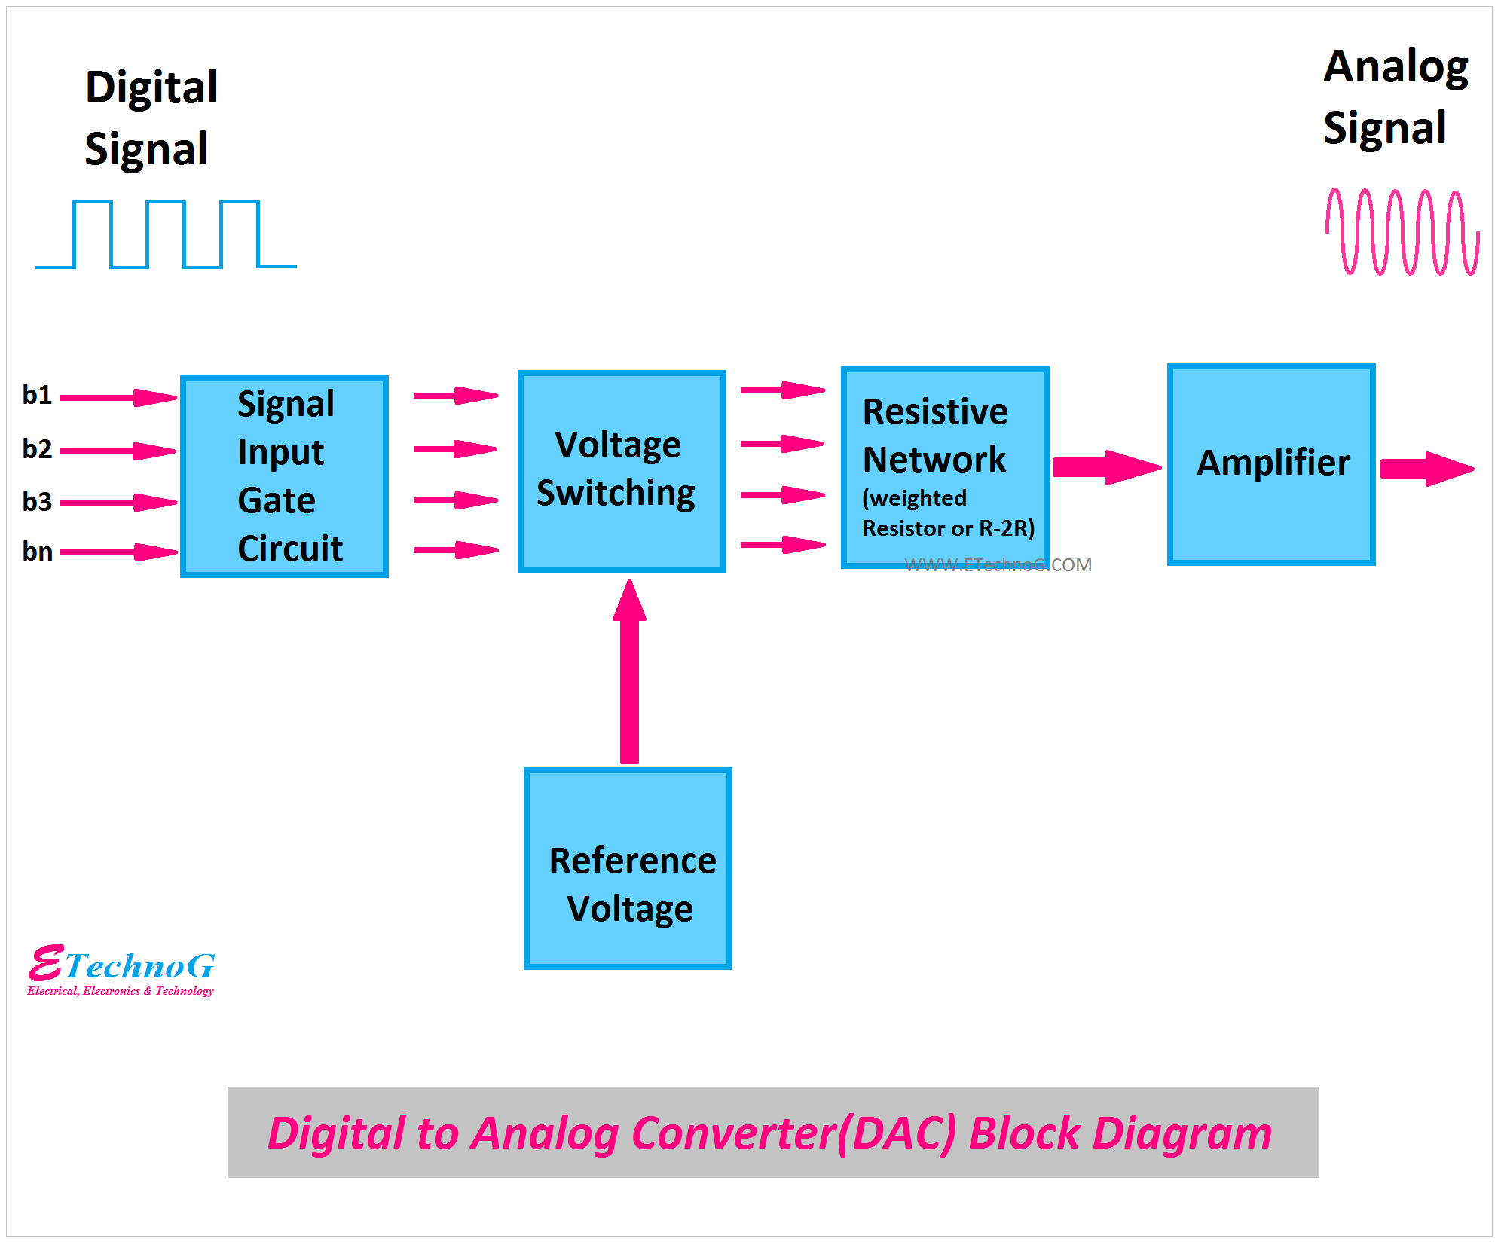

TOPIC 7:

**Key Stages in the Evolution of VLSI Technology**

1. **Vacuum Tube Era**
   * Before VLSI, vacuum tubes were used in electronic devices for amplification and switching.
     + *Example*: Early radios and computers relied on vacuum tube technology.
2. **Transistor Era**
   * The invention of transistors in the 1940s revolutionized electronics by enabling smaller, faster, and more reliable circuits.
     + *Example*: Transistors replaced bulky vacuum tubes in computers.
3. **Small-Scale Integration (SSI)**
   * In the 1960s, SSI introduced chips containing a few transistors, enabling basic logic operations.
     + *Example*: Flip-flop circuits used in early calculators.
4. **Medium-Scale Integration (MSI)**
   * MSI improved integration by combining hundreds of transistors on a single chip.
     + *Example*: Logic gates and multiplexers for basic computing tasks.
5. **Large-Scale Integration (LSI)**
   * LSI emerged in the 1970s, with thousands of transistors per chip, enabling microprocessors and memory units.
     + *Example*: Intel 4004, the first commercially available microprocessor.
6. **Very Large-Scale Integration (VLSI)**
   * VLSI integrated millions of transistors onto a single chip, leading to compact, high-performance devices.
     + *Example*: Modern CPUs and GPUs used in smartphones and computers.
7. **Ultra-Large-Scale Integration (ULSI)**
   * ULSI advanced VLSI technology further, integrating billions of transistors for cutting-edge applications.
     + *Example*: AI accelerators and high-performance processors like Apple’s M1.
8. **Emerging Trends**
   * Current advancements focus on **3D ICs**, **low-power designs**, and **AI-enhanced chips**, ensuring higher efficiency and performance in modern devices.
     + *Example*: Chips used in autonomous vehicles and IoT devices.

These stages showcase the rapid evolution of VLSI technology, shaping today’s tech-driven world.

1. Street Lighting

The street lights get automatically switched on in the evening and switched off in the sunlight. This is because they sense the brightness and the darkness due to the presence of photoresistors in them. The resistance of the photoresistors changes with the change in the intensity of the light, by using this phenomenon the circuits of the street lights are designed, and they automatically switched on and off during the night and day respectively. The position of the photoresistors is adjusted in such a way that factors other than sunlight, say, car headlights or bird’s shadow do not affect the working of the streetlights. Photoresistors also find their applications in burglar alarms and photographic devices.

Digital Logic Circuit Question - 3

2. Laptop and Mobile Chargers

Laptops and mobile chargers contain many resistors in them as they control the flow of current and dissipate heat. Various current readings like 1 A, 2A, 500mA, 700mA, etc., are inscribed on every charger; these readings represent the amount of current that a particular charger can allow to pass through the mobile or laptop and the speed of the charger in charging the devices.

3. Temperature Control

The temperature or heat in the circuit can be varied by changing the resistance in the circuit. This can be understood by Joule’s law of heating; Joule’s law states that the heat in the circuit is directly proportional to the square of the current (I), Resistance (R), and time (t), i.e., H=

I

2

I

2

​

RT. So, it is clear from this expression that the temperature of the circuit can be varied by varying the values of current, time, and resistance.

Resistor Use in Controlling the Temperature in the Circuit

4. Fan Speed Controller

We can change the speed of the ceiling fans by rotating the knob present on the circuit board. This knob is attached to a variable resistor, called a potentiometer. When we rotate that knob, the resistance values change that results in a change in the electric current. Hence, the speed of the fan can be controlled by using the potentiometer.

Learn Introduction To Uniform Circular Motion in 3 minutes.

5. Measuring Electrical Current

If we connect the resistors of known resistance in series, then the electric current in the circuit can be calculated by measuring the voltage drop across the resistor; this resistor is known as a shunt resistor, and they usually have high power ratings and low resistance value. The electric current in the circuit is calculated with the help of Ohm’s law (V=IR) by using the known values of current and voltage across the terminal.

A peek at the Circuit Theorems through GIFs - Docsity

6. Temperature Sensor

The temperature sensors are used to measure the degree of hotness or the coolness of both living and non-living things. Thermistors are used in temperature sensors because they can easily detect small changes in the temperature as the change in the temperature of the body is directly proportional to the change in the resistance of the diode. If the temperature of the body is low, then the resistance will also become low, but if the temperature of the body is high, then the resistance will also be high. The resistance is thus detected and measured by the temperature sensor and is converted into electrical signals, which give us readable units of temperature like Fahrenheit, Celsius, etc.

7. In-Circuit Functioning

Many electrical devices in which current controlling is required such as changing the musical pitch of the tone, loudness of an amplifier, speed of the electric motors, uses variable resistors in them. Variable resistors allow us to change the amount of current flow in these devices by changing the resistance by simply sliding or rotating the knob.

Fading/Controlling led/brightness using Potentiometer (Variable Resistor) and Arduino Uno

8. Dividing Voltage

Resistors are used in electrical circuits as voltage dividers. A voltage divider divides the source voltage into different parts of the electric circuits and gives the desired operating voltage at the output or the load terminal. In accordance with Ohm’s law, the voltage drop is high for the high resistance and low for the low resistance. The simplest voltage dividing circuit consists of two resistors (R1 and R2) connected in series that give lesser output voltage (Vo) than the source voltage (Vs) as per the requirement at the output terminal.

The output voltage can be calculated by the given formula,

Vo=Vs(R2/R1+R2)

Where Vo is the output voltage, Vs is the source voltage, R1 and R2 are the resistance of the resistors connected in series.

Voltage Dividing Circuit Using Resistors

Voltage Dividing Circuit

9. Heating Appliances and Lighting

Heating appliances like heaters, kettles, toasters, and electric ovens, use resistors in them. Resistors turn the electric current into heat and slowly dissipate this heat to make the appliances warm. The filament in the light bulb used in these heat appliances also behaves as a resistor as it reduces the current and heats up the filament wire until it glows. The heat dissipated by the resistors is measured in terms of heating power (Watts), which is given by,

P=

I

2

I

2

R

Where P is the heating power (watts), I is the electric current in the circuit (amps), and R is the resistance offered by the resistor (ohms).

Light bulb GIFs - Get the best gif on GIFER

10. LEDs & Transistors Protection

Transistors and LEDs are very sensitive to the electric current. The overflow of electric current can disrupt the sensitive components of these devices, and very little current in the circuit can affect their proper functioning. A resistor of the fixed values is connected in series with the led as they allow only the defined value of the current range to pass through these devices. Resistors that are used in LEDs are often known as ballast resistors; ballast resistors minimize the current flow in LEDs and protect them from getting burnt. The resistance of the ballast resistor is calculated by an expression derived by using Kirchhoff’s law and Ohm’s law, which is given by,

R=(V-

V

L

E

D

V

LED

​

)/I

Where V is the voltage of the source,

V

L

E

D

V

LED

​

is the voltage across the led, and I is the current at which the led is operating.

LED Ballast Resistor

11. Timing Circuits

Resistors are used in various devices like electronic sirens, light flashers, and various other similar devices that consist of timing circuits. The timing circuit consists of either resistors and capacitors combination (RC) or resistors and inductor combination (RL) that are connected in series or in parallel with each other. Capacitors and inductors are used to store the energy supplied by the voltage source; capacitors retard the change in the voltage, while inductors retard the change in the electric current. The ability of the capacitor and inductor to charge themselves depends upon the amount of resistance used in the circuit, they take a long time to charge up if the resistance is high or vice-versa. The time value of the circuit can be obtained by multiplying the value of resistance (in terms of ohms) by the value of the capacitor (in terms of farads) or inductor (in terms of henry). The time period of the circuit can be increased by increasing the resistance in the circuit as the electric current in the circuit gets slow down.

Time Delay Circuit with Resistor and Capacitor

Time Delay Circuit with Resistors and Capacitors.

12. Lighting Circuits in Houses

Parallel circuits of resistors are preferred over the series circuits in the lighting systems in homes because if we connect resistors in the series, then every bulb of the home gets switched off if we turn off only one light bulb. Moreover, the voltage is not the same across all the loads in the series, a larger number of loads means less voltage per load, and the farther away load from the source will get the least voltage. Hence, we use parallel resistor circuits as in this case, the voltage across each load becomes equal, and all the light bulbs won’t get switched off just by switching off any one of the bulbs in the circuit as each bulb in the parallel circuit has its own voltage source.

Circuit GIF by hlucier | Gfycat

13. Blower Motor Resistor

A Blower motor is used to run a fan that maintains the air ventilation system of the cars. The blower resistor is connected in series to the blower fan so that the current passing through the blower motor can be controlled by changing the resistance of the blower motor. Blower resistors consist of several resistors, which are used to control the speed of the fan as when we change the resistance the current passing through the motor reduces, which lowers the fan speed. Various designs are used for the construction of blower resistors that involve different sized wire-wound resistors are placed in series for controlling each fan speed, and in other designs, integrated circuits are mounted on the PCB (printed circuit boards).

Blower Motor Resistor

14. Filter Circuits

Resistors are used in filtering circuits of cell phones and computers that help in damping out unwanted electrical signals. Passive components like a capacitor or inductor are used along with resistors in these filter circuits. The filter circuit acts as a low or high-pass filter (a low-pass filter permits frequencies of lower range to pass through the circuit while high-pass filter permits frequencies of high range to pass through the circuit), depending upon the position of the resistor in the circuit. These circuits block unwanted frequency ranges and only allow the desired frequency ranges to pass through the electric circuit.

Use of Resistor in Filter Circuits

15. Fusible Resistors

The fusible resistor is actually a wire-wound resistor. It works as a normal resistor that limits the electric current at the given power supply, but if the power supply exceeds the normal value, then it acts like a fuse, and it gets burned, and it is turned into an open circuit, protecting the devices from the short-circuit. So, fusible resistors can be used to perform dual functions, i.e., as a fuse and as normal resistors in the electric circuits.

TRANSISTOR:

DEFINITION:

A transistor is a device that controls an electrical current by amplifying, facilitating or stopping it. Transistors can be found in computer memory chips, cell phones and car engines, among other applications.

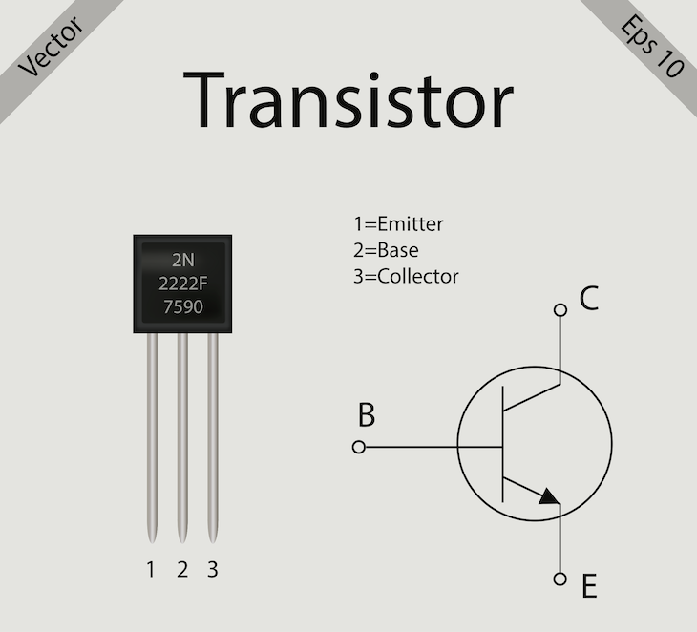

TYPES OF TRANSISTOR:

* 1. BJT(base emmiter junction)
  2. FET

BJT:

A Bipolar Junction Transistor (also known as a BJT or BJT Transistor) is a three-terminal semiconductor device consisting of two p-n junctions which are able to amplify or magnify a signal. It is a [current](https://www.electrical4u.com/electric-current-and-theory-of-electricity/) controlled device. The three terminals of the BJT are the base, the collector and the emitter. A BJT is a type of [transistor](https://www.electrical4u.com/working-principle-of-transistor/) that uses both electrons and holes as charge carriers.

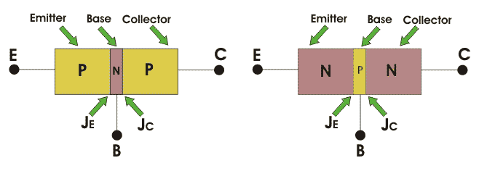

**NPN Bipolar Junction Transistor**

In an **n-p-n bipolar transistor** (or [npn transistor](https://www.electrical4u.com/npn-transistor/)) one p-type semiconductor resides between two n-type semiconductors the diagram below an n-p-n transistor is shown  
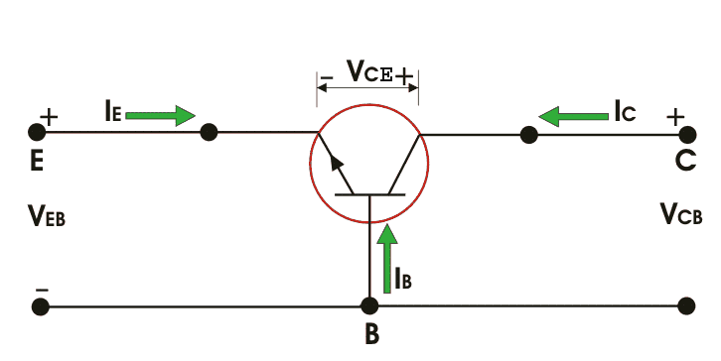

**PNP Bipolar Junction Transistor**

Similarly for **p-n-p bipolar junction** transistor (or [pnp transistor](https://www.electrical4u.com/pnp-transistor/)), an n-type semiconductor is sandwiched between two p-type semiconductors. The diagram of a p-n-p transistor is shown below  
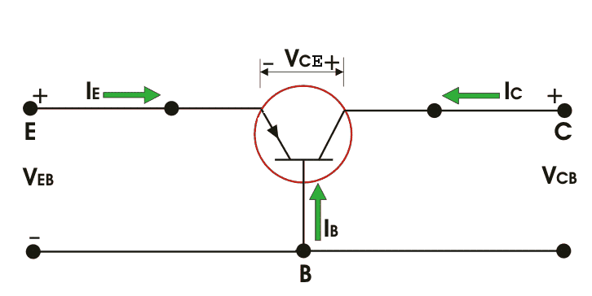

**Bipolar Junction Transistors Characteristics**

The three parts of a BJT are collector, emitter and base. Before knowing about the **bipolar junction transistor characteristics**, we have to know about the modes of operation for this [type of transistors](https://www.electrical4u.com/types-of-transistors/). The modes are

1. Common Base (CB) mode
2. Common Emitter (CE) mode
3. Common Collector (CC) mode

All three types of modes are shown below  
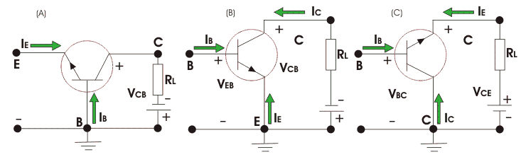

AND GATE SIMULATION:

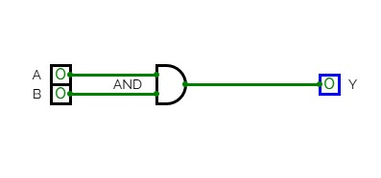

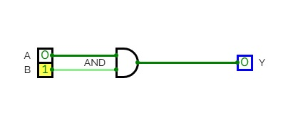

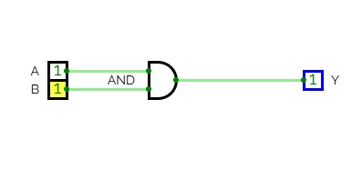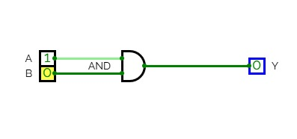

OR GATE SIMULATION:

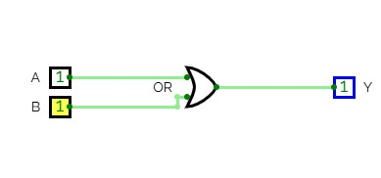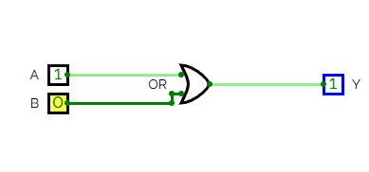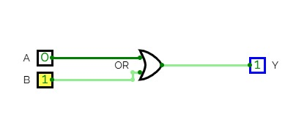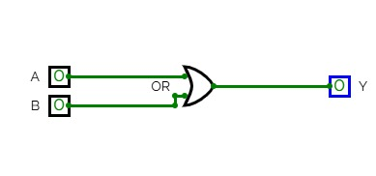

NOT GATE SIMULATION:

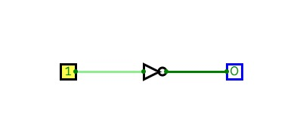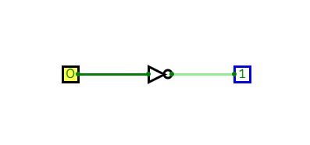

XOR GATE:

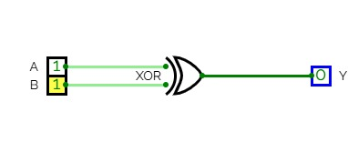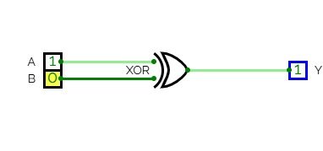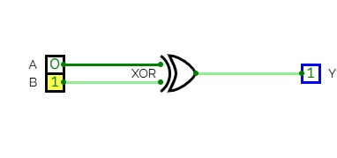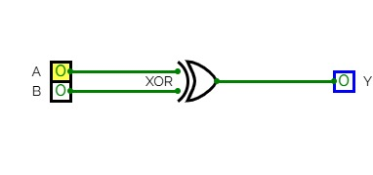

NAND GATE SIMULATION:

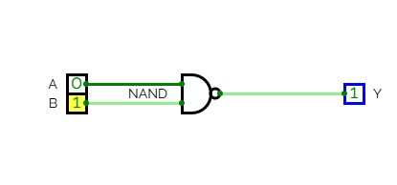

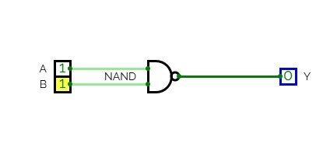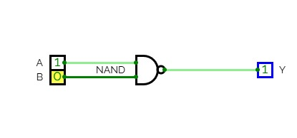

NOR GATE SIMLATION:



XNOR GATE SIMULATION:

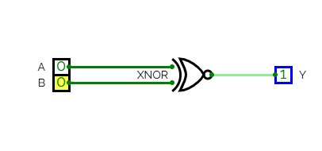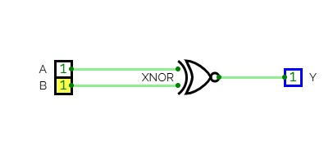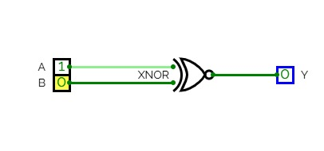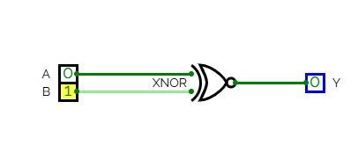

VLSI CODE FOR AND GATE:

**Testbench:**

**module** tb_and_gate;  
 reg A, B;  
 wire Y;  
  
 and_gate uut (.A(A), .B(B), .Y(Y));  
  
 **initial** **begin**  
 $display("A B | Y");  
 A = 0; B = 0; #10; $display("%b %b | %b", A, B, Y);  
 A = 0; B = 1; #10; $display("%b %b | %b", A, B, Y);  
 A = 1; B = 0; #10; $display("%b %b | %b", A, B, Y);  
 A = 1; B = 1; #10; $display("%b %b | %b", A, B, Y);  
 $finish;  
 **end**  
**endmodule**

**Verilog Code:**

**module** and_gate(input A, input B, output Y);  
 **assign** Y = A & B;  
**endmodule**

VLSI CODE FOR OR GATE:

**Testbench:**

**module** tb_or_gate;  
 reg A, B;  
 wire Y;  
  
 or_gate uut (.A(A), .B(B), .Y(Y));  
  
 **initial** **begin**  
 $display("A B | Y");  
 A = 0; B = 0; #10; $display("%b %b | %b", A, B, Y);  
 A = 0; B = 1; #10; $display("%b %b | %b", A, B, Y);  
 A = 1; B = 0; #10; $display("%b %b | %b", A, B, Y);  
 A = 1; B = 1; #10; $display("%b %b | %b", A, B, Y);  
 $finish;  
 **end**  
**endmodule**

**Verilog Code:**

**module** or_gate(input A, input B, output Y);  
 **assign** Y = A | B;  
**endmodule**

VLSI CODE FOR NOT GATE:

**Testbench:**

**module** tb_not_gate;  
 reg A;  
 wire Y;  
  
 not_gate uut (.A(A), .Y(Y));  
  
 **initial** **begin**  
 $display("A | Y");  
 A = 0; #10; $display("%b | %b", A, Y);  
 A = 1; #10; $display("%b | %b", A, Y);  
 $finish;  
 **end**  
**endmodule**

**Verilog Code:**

**module** not_gate(input A, output Y);  
 **assign** Y = ~A;  
**endmodule**

VLSI CODE FOR XOR GATE:

**Testbench:**

**module** tb_xor_gate;  
 reg A, B;  
 wire Y;  
  
 xor_gate uut (.A(A), .B(B), .Y(Y));  
  
 **initial** **begin**  
 $display("A B | Y");  
 A = 0; B = 0; #10; $display("%b %b | %b", A, B, Y);  
 A = 0; B = 1; #10; $display("%b %b | %b", A, B, Y);  
 A = 1; B = 0; #10; $display("%b %b | %b", A, B, Y);  
 A = 1; B = 1; #10; $display("%b %b | %b", A, B, Y);  
 $finish;  
 **end**  
**endmodule**

**Verilog code:**

**module** xor_gate(input A, input B, output Y);  
 **assign** Y = A ^ B;  
**endmodule**

ANDROID AND IPHONE

STAGE 1;

WHAT IS ANDROID AND WHY TO USE IT?

* Android is an open-source and Linux-based operating system.
* It was first introduced on Nov 5, 2007.
* It was originally developed by Android Inc.
* and subsequently purchased by Google.
* Basically, [**Android**](https://www.android.com/intl/en_in/what-is-android/) is thought of as a mobile operating system.
* But it is not limited to mobile-only. It is currently used in various devices such as mobiles, tablets, televisions, etc.
* Android provides a rich application framework that allows us to build innovative apps and games for mobile devices in a Java language environment.
* The Android open-source software stack consists of Java applications running on a Java-based, object-oriented application framework on top of Java core libraries running on a Dalvik virtual machine featuring JIT compilation.

WHY ANDROID?

There are so many reasons you should choose the Android platform for mobile application development.

1. Zero/negligible development cost

The development tools like Android SDK, JDK, and Eclipse IDE, etc. are free to download for the android mobile application development. Also, Google charges a small fee of $25, to distribute your mobile app on the Android Market.

1. Open Source

The Android OS is an open-source platform based on the Linux kernel and multiple open-source libraries. In this way, developers are free to contribute to or extend the platform as necessary for building mobile apps which run on Android devices.

1. Multi-Platform Support

In the market, there is a wide range of hardware devices powered by the Android OS, including many different phones and tablets. Even the development of android mobile apps can occur on Windows, Mac OS, or Linux.

1. Multi-Carrier Support

World wide a large number of telecom carriers like Airtel, Vodafone, Idea Cellular, AT&T Mobility, BSNL, etc. are supporting Android-powered phones.

1. Open Distribution Model

[**Android Market place (Google Play store)**](https://play.google.com/store/apps/details?id=com.google.android.finsky&hl=en_IN&gl=US)has very few restrictions on the content or functionality of an android app. So the developer can distribute their app through the Google Play store and as well other distribution channels like Amazon’s app store.

STAGE 2;

ANDROID FEATURES;

Web browser(internet access)

Multi touch(touch interaction)

Bluetooth(wireless technology)

Tethering(internet sharing)

Ethernet(wired connection)

External storage(storage expansion)

Messaging(text communication)

Auto correction and dictionary(text correction)

Voice based feature(voice commands)

Screen capture(screen shot)

Multitasking(simultaneous apps)

STAGE 3;

